**Theory of Operation for a Prototype Irradiance Meter**

**Alex Polyanskiy**

**Introduction**

The solar industry is growing every year due to the increasing popularity in renewables. Installation and maintenance of Photovoltaic panel in all locations and applications require various measurements, one of which is solar irradiance. Solar irradiance is the power receive from the sun per unit area, measured in watts per meter squared (W/m­­2). Three main types of sensors are used to measure similar irradiance that is seen by the solar panels. A thermopile sensor is the most accurate and durable, but it is also the most expensive and the largest. In addition, it is not spectrally selective, meaning it reacts to all wavelengths in the same way. Photovoltaic panels are spectrally selective, so spectral mismatch correction need to be done if irradiance is not close to AM1.5 [1]. Photodiode sensors are cheap, but have a different solar spectrum than that of a solar panel. Spectral mismatch correction needs to be done if an accurate measurement is necessary. Solar reference cells sensors are slightly more expensive than photodiodes and match the solar spectrum of the solar panel if made out of the same material. In some cases, a filter can be placed over the solar cell to adjust the solar spectral to match a different type of solar panel. For a portable handheld device, the best sensor to use is either a photodiode or a reference cell due to the low cost and size.

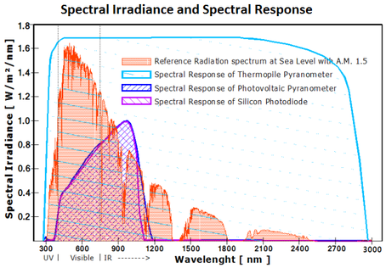

**Reference Solar Cell vs Photodiode**

A reference cell would only have to be spectral corrected if the panel that is being tested is made out of different material. A photodiode would have to be spectrally corrected for every type of solar panel to achieve the same accuracy as the reference cell. In both cases the meter would read the irradiance seen by the sensor and then the irradiance correction would be done by the I-V curve tracer(assuming the curve tracer would get the spectral response of the solar panel being tested.) The spectral response of the sensor would have to be obtained in lab during calibration. [3]

Temperature has a large effect on the open circuit voltage and a small effect on the short circuit current. For the solar cell being considered, the temperature coefficient for the open circuit voltage is -1.7 mV/K and the temperature coefficient for the short circuit current is 26.5 µA/K. So as the temperature changes, the voltage will have a significantly larger change than the current. The effect is similar with photodiodes. Even though the effect is small, it should still be taken into account for instances where the temperature varies greatly from the reference temperature. A reference cell can make contact with a thermistor which will record the temperature and that value will be used in the irradiance calculation. Temperature does affect photodiodes as well. A way to account for it is to have a heating system in the device that would keep the temperature constant. Considering both methods, correcting for temperature in the reference cell will lead to higher accuracy and less expenses.

The cost for a photodiode is slightly less than a solar cell. The cheap solar cells would have to be tested to make sure the datasheet values are correct. If the design requires more than one solar cell, that would also drive the cost up.

A reference cell with temperature compensation will give a more accurate results at a slightly higher cost. The majority of solar panels on the market are made out of a crystalline structure. Using a monocrystalline solar cell as a sensor will match most of the panels being used. This means a spectral mismatch is not necessary in most cases. Below is a comparison chart.

|  |  |  |
| --- | --- | --- |
| **Sensor Type** | **Positive** | **Negative** |
| **Reference cell** | * Closely matches PV spectral response * Few competitors * BK7 glass as a window to protect the sensor from dust * Standards provide information for calibration and packaging * Standards provide information for irradiance correcting for I-V curve tracer * Can be corrected to temperature * Can put filter over to match different solar panels | * Would need to find spectral mismatch factor if the solar panel is made out of different material * Would have to test solar cell to make sure the ISC and VOC are correct * Need more reference cells to increase accuracy * BK7 glass is expensive * Will only see 160o |
| **Photodiode** | * Need only one photodiode * Can find photodiode with a similar sensitivity as solar cells * Similar devices available for reference * Cheaper than solar cell * Cosine corrected view angle | * Need to account for dark current * For increased accuracy need to find the mismatch factor * Similar devices do not account for temperature (decreased accuracy) * A lot of competitors * Need a filter to be cosine corrected * Need to account for temperature |

**Reference Cell Standards**

General measurement requirements given in **IEC 60904-1**

* The irradiance measurements shall be made using a PV reference device packaged and calibrated in conformance with IEC 60904-2
* The PV reference device shall either be spectrally matched to the test specimen, or a spectral mismatch correction shall be performed in conformance with IEC 60904-7
* The reference device shall be linear in short-circuit current as defined in IEC 60904-10 over the irradiance range of interest
* The temperature of the reference device and the specimen shall be measured using instrumentation with an accuracy of ±1 °C with repeatability of ±0,5 °C
* The active surface of the specimen shall be coplanar within ±2° with the active surface of the reference device
* Voltages and currents shall be measured using instrumentation with an accuracy of ±0,2% of the open-circuit voltage and short-circuit current using independent leads from the terminals of the specimen and keeping them as short as possible
* The short-circuit current shall be measured at zero voltage, using a variable bias (preferably electronic) to offset the voltage drop across the external series resistance

Highlights of photovoltaic reference device requirements given in **IEC 60904-2**

* The output signal of the reference device shall vary linearly with irradiance, as defined in IEC 60904-10, over the range of interest
* The presence or absence of bypass diodes shall be noted and considered in conjunction with the measurement conditions, in particular spatial non-uniformity of the irradiance on the module during measurement
* The resistor shall be chosen such as to ensure that the reference device operates sufficiently near to short-circuit condition, meeting the requirement:

*ISC x RCAL* < .03 x *VOC* (1)

Where

RCAL is the shunt resistor;

ISC is the short circuit current of the reference device at reference conditions;

VOC is the open circuit voltage at reference conditions.

* It is recommended that the shunt resistor be a removable 4-wire resistor, to allow for periodic checking of the reference device stability by taking an I-V curve per IEC 60904-1
* The required uncertainty for cell temperature measurements shall be less than ± 2,0 °C for all reference devices. A minimum accuracy of ±1,0 °C for the temperature sensor is suggested to achieve this uncertainty in the temperature measurement.
* The electrical connections to reference cells shall consist of a four-wire contact system (Kelvin probe)
* Methods for calibrating primary reference devices are included in IEC 60904-4
* The temperature coefficient of each reference device shall be measured in accordance with IEC 60891
* The field of view should be at least 160° in the package
* All surfaces in the package within the cell’s field of view should be non-reflective, with an absorption of at least 0,95 in the cell’s wavelength responsivity band
* The use of a protective window is recommended. If encapsulated, the space between the window and the cell should be filled with a stable encapsulant
* The protective window may embody a filter to match the spectral responsivity of the reference cell to that of the test specimen
* Calibration under natural sunlight, simulated sunlight, and another reference cell are included in this standard

Spectral Mismatch factor calculation **IEC 60904-7**

* (2)

Where

Geff as ref spectrum  is the effective irradiance of the test specimen spectrum;

Gmeas is the irradiance as measured by the reference device;

MM is the spectral mismatch factor.

* (3)

Where

Eref(λ) is the irradiance per unit bandwidth at a particular wavelength λ,

of the reference spectral irradiance distribution;

Emeas(λ) is the irradiance per unit bandwidth at a particular wavelength λ, of the spectral irradiance distribution of the incoming light at the time of measurement;

S­­ref(λ) is the spectral response of the reference PV device;

Ssample(λ) is the spectral response of the test PV device.

* In the case, that absolute spectra and absolute spectral responses are used for the analysis, Equation 3 can be interpreted as

(4)

Where

Isc, sample, Eref is the short-circuit current of the rest sample under the reference spectrum;

Isc, ref, Eref is the short-circuit current of the reference device under the reference spectrum;

Isc, sample, Emeas is the short-circuit current of the test sample under the measured spectrum;

Isc, ref, Emeas is the short-circuit current of the reference device under the measured spectrum;

Because .

Temperature and irradiance correction **IEC 60891**

* (5)

Where

G is the irradiance;

IRC is the short-circuit current;

IRC,STC is the short-circuit current at STC;

TRC is the temperature of the cell;

αRC is the temperature coefficient of the cell.

* This standard also includes procedures for correcting current and voltage measurement, determining temperature coefficients, determining internal series resistances, and determining curve correction factors

Standard Test Conditions **IEC 61829**

* module temperature: 25 °C
* in-plane irradiance: 1 000 W/m2
* spectral distribution: AM 1,5 (global)

Calibration of a secondary reference device against a primary reference device

This procedure simplifies the information given in IEC 60904-2 for calibration against a primary reference device. A primary reference device is defined as: a photovoltaic reference device whose calibration is based on a radiometer or standard detector or standard light source traceable to SI units as defined in IEC 60904-4. The following process requires a solar simulator as the light source rated AAA(IEC 60904-9). Since the procedure requires simultaneous irradiance measurements of the primary reference device and the secondary reference device under the same light source, it is important that the light source has a non-uniformity of less than ±1%.

1. Measure the spectral responsivity and temperature coefficient of short circuit current of the secondary reference device (IEC 60904-8 and IEC 60891)
2. Mount the primary device and secondary device co-planar (±1º) and normal to the light source (±5º)
3. Record simultaneous readings of the output signal and temperature of the primary and secondary device
4. Repeat step 3 until five successive sets of readings are obtained where the ratio of the output signals does not vary by more than ±0.5%
5. note: output signals need to first be corrected to 25ºC (IEC 60891) and for spectral mismatch(only required if the cells are made of different technologies, IEC 60904-7)
6. Exchange the positions of the primary and secondary devices and repeat step 4 and 5
7. Calculate the ratio:
8. Multiply the calibration value of the primary device by the mean of the ratios to obtain the calibration value of the secondary reference device
9. calculate the calibration value for both cases(before the location exchange and after) and average the value
10. calibration values for both cases must agree within the measurement uncertainty (±.5%)

**Design**

The main purpose of the device is to measure irradiance, but taking a few other measurements will make the device versatile. Measuring ambient temperature and the angle of the device will help with installation and maintenance of the solar panels in the field. In addition, Bluetooth is becoming more popular in the metrology industry, so incorporating Bluetooth connectivity is a useful feature. A power supple is required to power all the modules and the microcontroller which will make all the calculations and display the measurements on an LCD display. Below is a box diagram of the design.

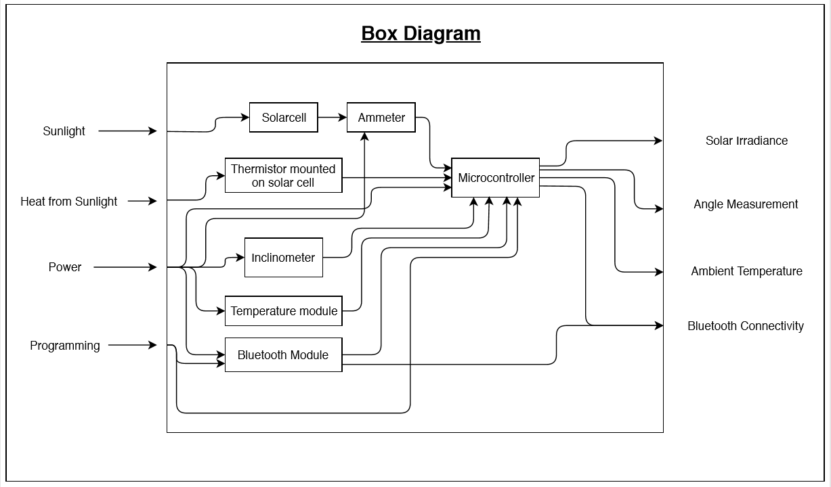

**Microcontroller**

The microcontroller picked for this design is the Photon made by Particle. It comes with 6 analog inputs, which will be used for the ammeter and the thermistor that will measure the solar cell voltage. The Photon also has 7 digital input pins, which will be used for the inclinometer, ambient temperature module, and Bluetooth module. The voltage required to power the photo is 3.6 to 5.5V and it can output 3.3V to power all other circuit components. A software engineer was given the task of programming the microcontroller.

**Power Supply**

The microcontroller required 3.6 to 5.5V so operate and power the rest of the circuit. Two AA batteries were put in series to create a 3.2V supply. Since the batteries would lose power with time, a step-up voltage regulator was implemented. The Fluke v3000 also runs on two AA battery and has a 5 V step-up voltage regulator called the Torex XC6372. In addition, the part has a maximum output current of 100 mA and the total current consumption by all the parts in the irradiance meter is 55.196 mA. The datasheet provided information on how to implement the part in the design. Below is a diagram of the circuit.

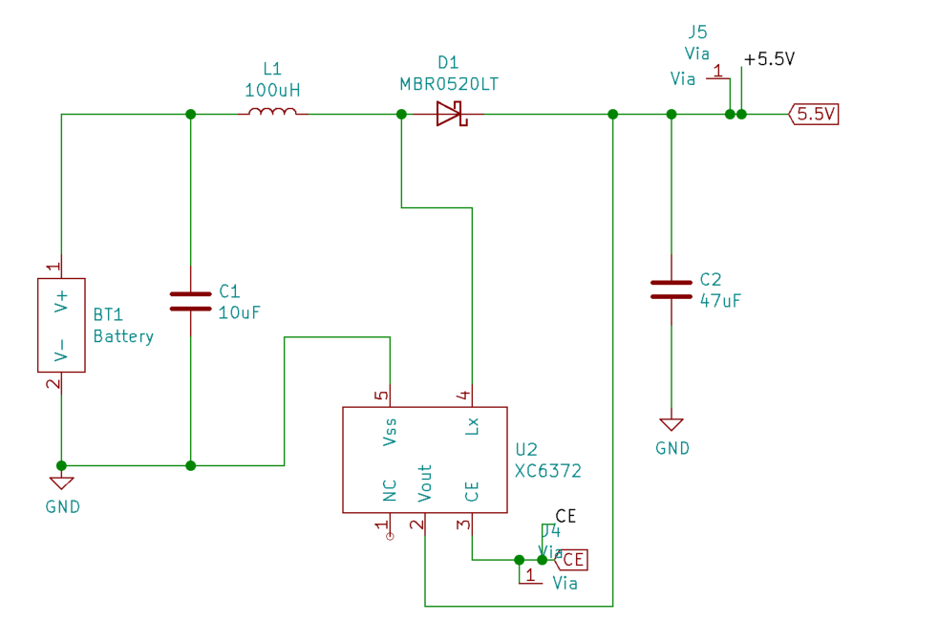

**Irradiance Measurement**

The irradiance measurement is going to be made by a monocrystalline solar cell. Irradiance is directly proportional to the current created by the sunlight in the solar cell. The current will be measured with a shunt resistor and a shunt monitoring op-amp. The value of the shunt resistor will be determined through equation (1).

Reference conditions are established to be at 1000 W/m2, air mass 1.5, and 25oC. The short circuit current and open circuit voltage measured at standard conditions are found in the data sheet for the solar cell, but for increased accuracy should be tested again. The solar cell will not be tested for this design.

The solar cell being used is the IXYS High Efficiency SolarBIT. The electrical characteristics are listed below:

VOC 690 mV

ISC 58.6 mA

Vmpp 560 mV

Impp 55 mA

Pmpp 30.7 mW

FF >70%

Efficiency 25%

ΔVOC/ΔT -1.7 mV/K

ΔISC/ΔT 26.5 uA/K

The values above are given at 1000W/m2. It is important to consider irradiance at a max value. The largest irradiance will be about 1200W/m2. Since irradiance is directly proportional to short circuit current, the following equation is used to find the ISC at 1200W/m2:

= , ISC = 70 mA

Next the max shunt resistance value was calculated. As irradiance increases, the open circuit voltage will increase slightly, but will not be affected as much as the current. Also keeping VOC, the same will cause the max shunt value to decrease so it was left unchanged:

(70 mA) x RSH < (.03) x (690 mV)

RSH < .296 Ω

The shunt resistor was chosen to be .08 Ω, which satisfied the standards and caused the max voltage reading across the shunt resistor to be 5.6 mV( when ISC = 70 mA). Since the microcontroller needs a high voltage to generate an accurate irradiance reading a shunt monitoring op am was place between the shunt resistor and the microcontroller. The op-amp gave a gain of 500, which brought the max voltage reading by the microcontroller to 2.8 V and the max input voltage for the analog pins is 3.6 V. The equation below was developed to calculate ISC of the solar cell:

(6)

Where

ISC is the short circuit current of the solar cell;

RSH is the shunt resistor (.08 Ω);

V is the voltage read by the microcontroller;

A is the gain (500 V/V).

In order to calculate irradiance seen by the solar cell, the temperature of the cell is also needed because current does vary with temperature. A through hole will be made under nether the solar cell on the PCB and thermal glue will be used to attach the thermistor to the cell through the hole. A 10kΩ resistor was placed in series with the thermistor since the thermistor resistance is 10kΩ at 25oC. The microcontroller supplies 3.3V to the circuit. The current running through the thermistor is found by measuring the voltage across the 10kΩ resistor and using Ohms law. The resistance of the thermistor is calculated using the current.

I10k resistor = Ithermistor = (7)

(8)

The datasheet provided an equation that can be used to calculate the temperature seen by the thermistor:

(9)

Where

Tc is the temperature of the cell;

B is the B-constant of the thermistor (3380 K);

To is the reference temperature (25oC);

R is the resistance of the thermistor at T;

Ro is the resistance of the thermistor at To;

Note the equation was manipulated to use oC instead of K

Equation 5 was rewritten and the short circuit current and the temperature was used to calculate the irradiance:

(10)

Where,

Ee is the effective irradiance,

ISC is the measured short circuit voltage,

Tc is the cell temperature,

To is the reference temperature (25oC),

α is the temperature coefficient for ISC,

ISCO is the reference short circuit current (58.6 mA)

All the calculations are done on the microcontroller and the effective irradiance value is then displayed on the LCD screen or through Bluetooth. The Microcontroller supplies power for the shunt monitoring op amp and the thermistor circuit. A diagram for the Irradiance sensor is displayed below.

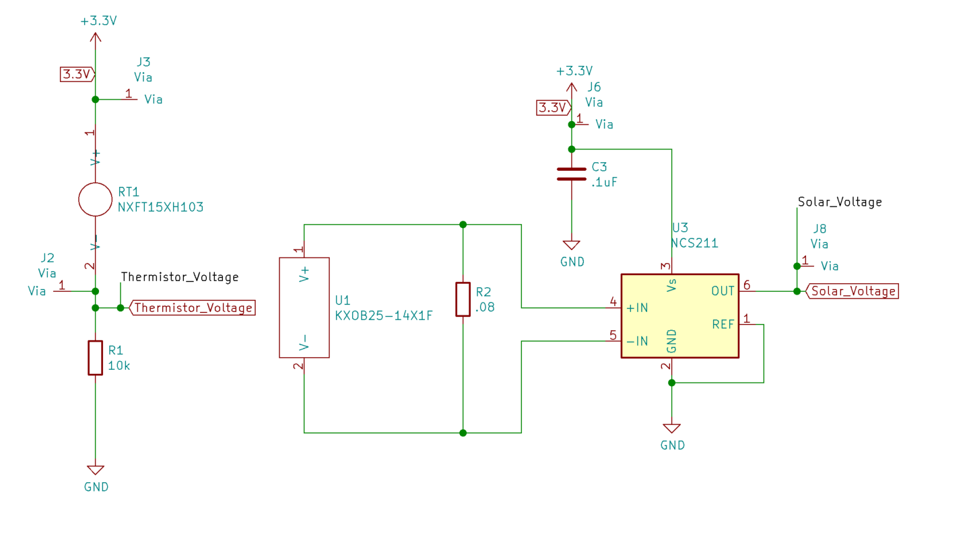

**Ambient Temperature Sensor**

To measure ambient temperature, the TMP36 from Analog Devices was selected as the analog temperature module. The sensor outputs 750 mV at 25oC and has a scale factor of 10 mV/oC with an accuracy of ±2°C. Below an equation was created for the output voltage of the part:

(11)

The operating temperatures are -40oC to 125oC and that is more than enough for the temperatures the device will be used in. The highest reasonable temperature the device would be in is 50oC, the voltage output at that temperature is calculated to be 1V. The max input voltage for the microcontroller is 3.6 V. A noninverting op-amp was added with a gain of 3 V/V to give the max voltage read by the microcontroller to be 3V. Below is a circuit diagram of the sensor.

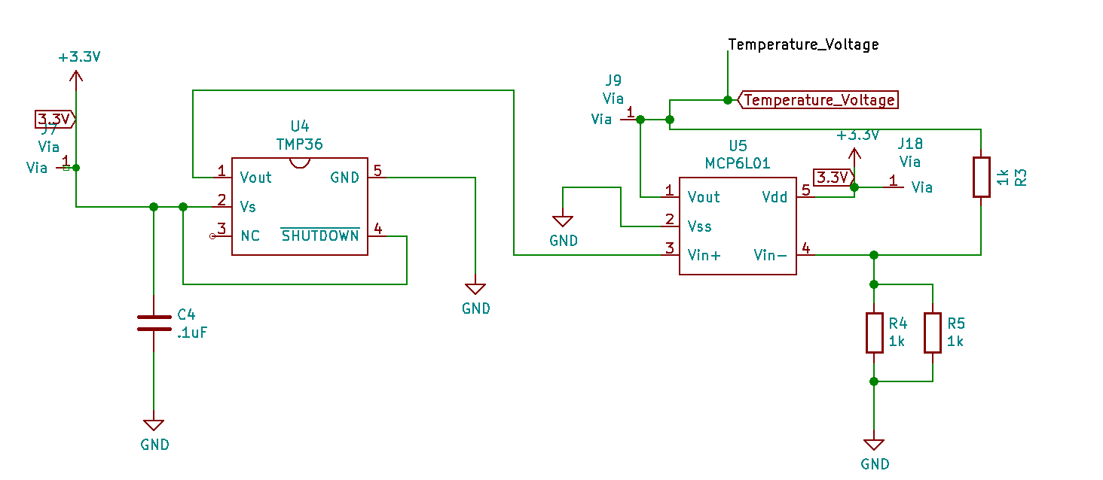

**Inclinometer**

An inclinometer would be useful in the field to measure the angle of solar panels or to find an angle that produces maximum irradiance. The Xtrinsic MMA8452Q was chosen due to the low power consumption, low cost, and low error. In addition, the accelerometer came with the libraries needed for the software engineer. The part would simply use one the digital inputs on the microcontroller and would not require any amplification.

**Bluetooth**

Having Bluetooth connectivity on the device would allow the device to connect to PC’s and smartphones to display and record data captured by the device. The Fanstel BT832 was chosen as the module due to the low power consumption, the ability to connect to Bluetooth 5.0, the FCC and IC certification, and the amount of memory. The programing and connection setup for the module was done by the software engineering.

**LCD**

The LCD is used to display the calculated values on the device itself. The Nokia 5110 was chosen due to the prebuilt libraries, large screen that can display all data values, and the low cost. The LCD would display the irradiance measurement, ambient temperature, and the angle of the device.

**Prototype Assembly**

A portion of the overall system was designed on KiCad and printed in house. The PCB layout is displayed below. The design was a 2-layer board that included the solar sensor, voltage regulator, ambient temperature sensor, and any amplification that was needed for each sub-system.

PCB Layout

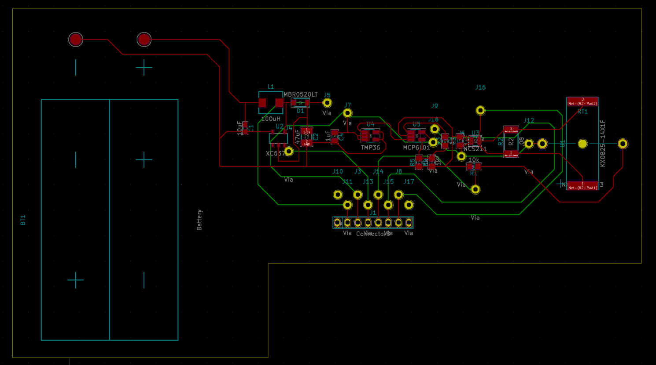

Irradiance Sensor

Ambient Temperature Sensor

Voltage Regulator

PCB 3D Layout

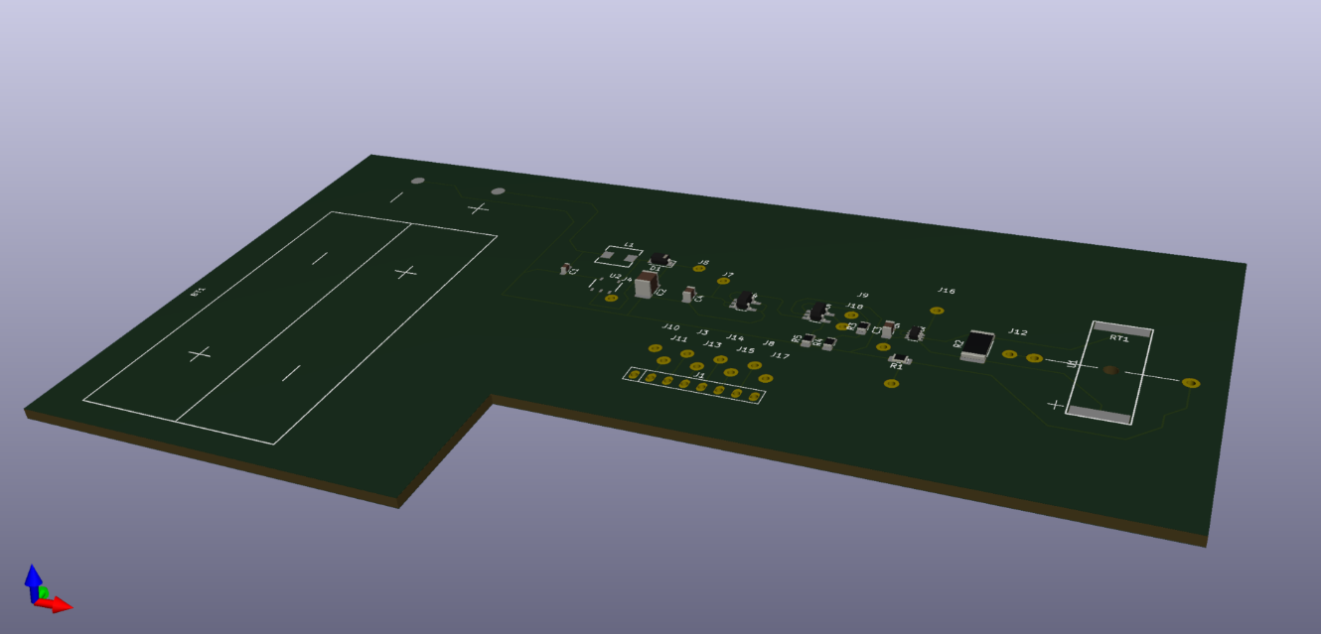

After the PCB was printed, the rest of the parts( microcontroller, inclinometer, and LCD) where wired to the PCB on a breadboard. An image of the assemble circuit is displayed below. Three buttons where added to circuit to provide display options for the LCD. The three display options were: Irradiance and angle, Ambient temperature and cell temperature, and max irradiance and angle. A switch was added between the battery and the voltage regulator to turn the meter on and off.

First Design Irradiance Meter

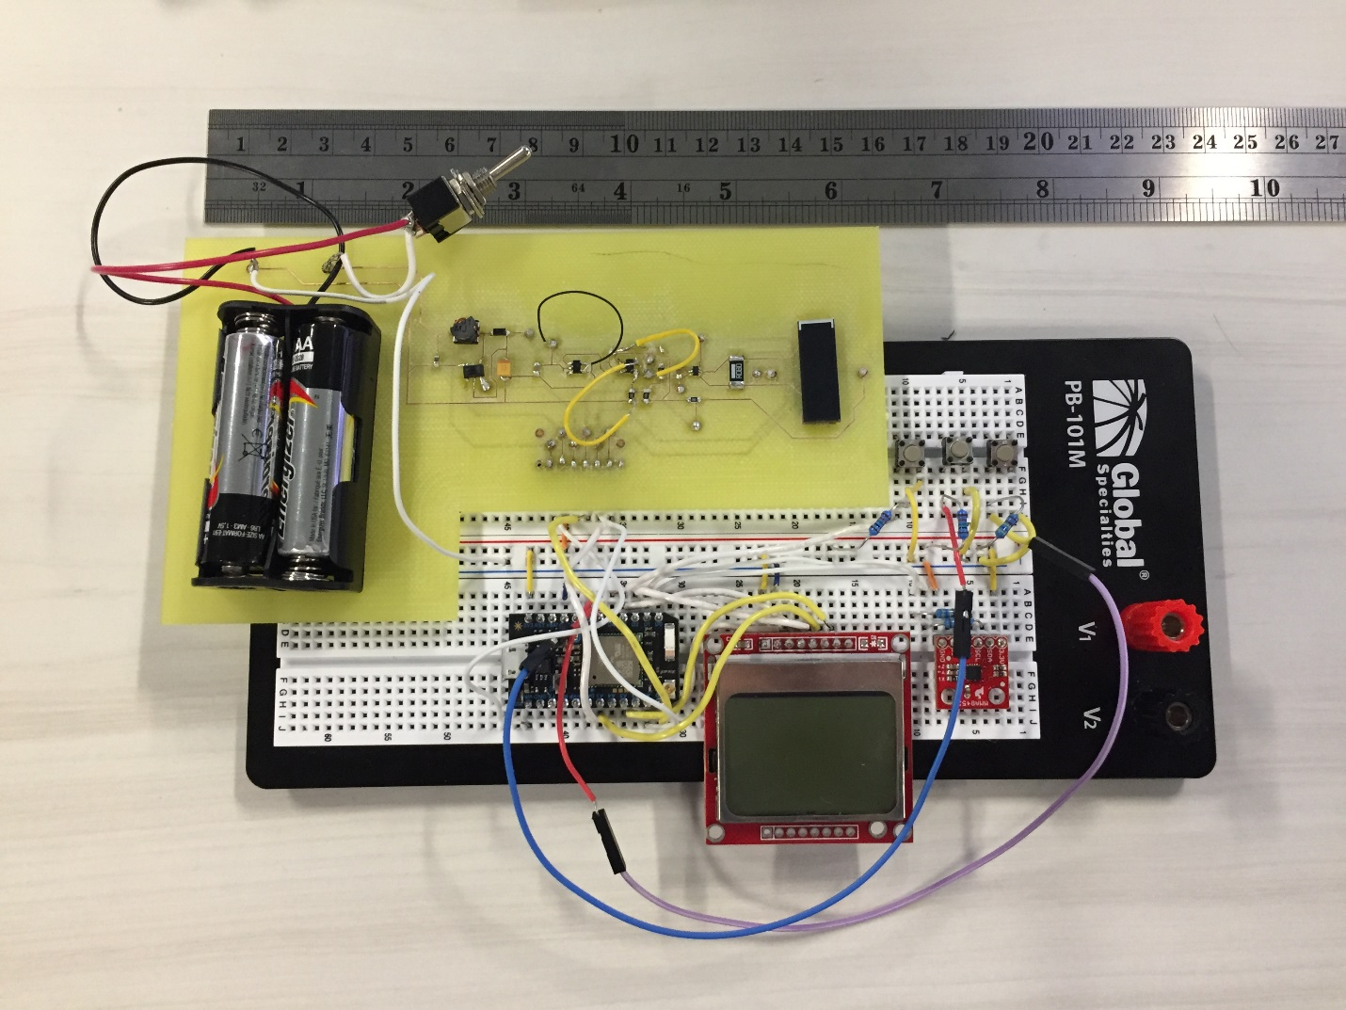

LCD

Microcontroller

Inclinometer

Buttons

Power Switch

The Bluetooth component had a smaller PCB designed to help with wiring. The KiCad PCB layout is displayed below. The Bluetooth module was not included in the circuit described above, but its functionality was tested by the software engineer.

Bluetooth PCB Layout

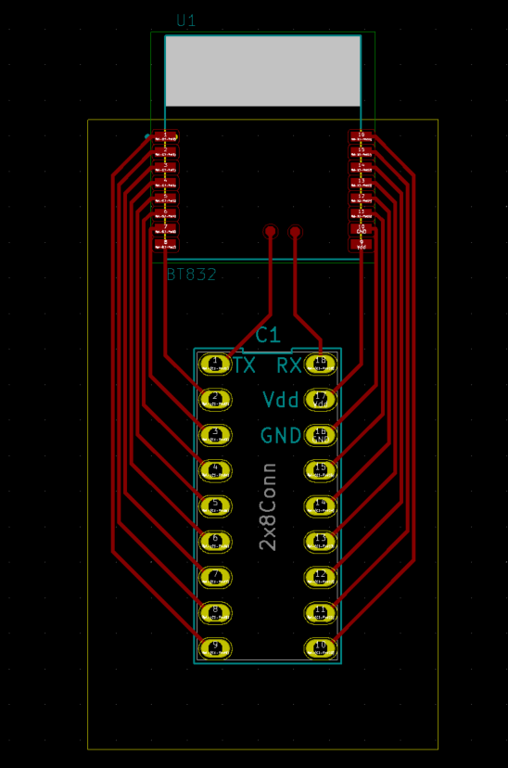 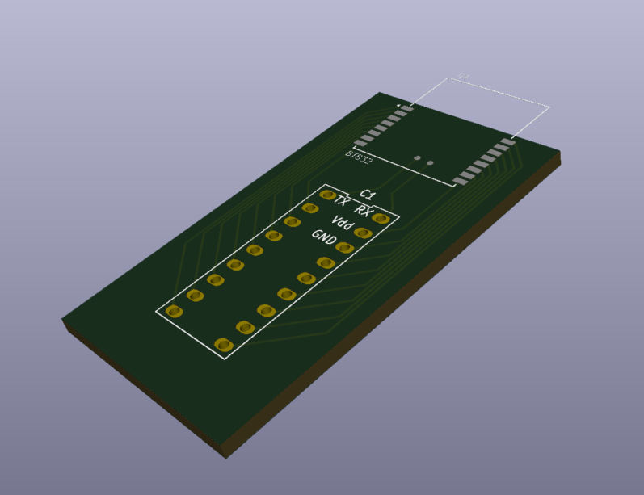

**Testing**

The design was tested in comparison to two other irradiance sensors, the Seaward Survey200R and the Solmetric SolSensor 300. The Seaward meter is a handheld meter that has a photovoltaic silicon solar cell as the sensor and error of 5-10%. The Solmetric is a photodiode based mounting irradiance meter with an error of 2%. It has temperature correction and spectral response correction to match silicon solar cells. Irradiance values were gathered over a few days at different irradiance values and the results are displayed below.

The testing location had no shade on the devices during testing. The data was gathered by taking the lowest and highest reading on each device over a short (typically 2 to 5 seconds) interval. The readings for each device were taken simultaneously. Testing time intervals were chosen at times of minimal cloud interference. It is important to note the geographical location is naturally cloudy. Since Icarus was a prototype without a case, wind was a large contributor, as it might cool the thermistor beneath the solar cell and lower the irradiance reading. Days with excessive or noticeably more substantial amounts of wind were labeled “wind” in the data. The dark blue on the graph represents the range of the Solmetric Solsensor irradiance measurements, while the dark orange represented the Seaward Survey200R and the dark yellow represented the prototype design.

Table 1

|  |  |  |  |
| --- | --- | --- | --- |
| Day & Time | Solsensor Irradiance Range (W/m2) | Seaward Irradiance Range (W/m2) | Design Irradiance Range (W/m2) |
| July 22, 1:00pm | 860 | 880-886 | 849-853 |
| July 23, 5:00pm | 60-70 | - | 50-65 |
| July 29, 11:00am | 750 | 750-754 | 733-756 |
| July 29, 5:30pm | 470 | 446-450 | 472-480 |
| July 30, 10:00am | 140-150 | 154-162 | 134-153 |
| July 30, 1:00pm | 920-930 | 914 | 876-890 |

**Data Analysis**

Since the Seaward device has a large error range, the design measurements were compared to the Solmetric device. The Solmetric Solsensor was assumed to display the correct irradiance at the time of the measurements. It is important to note that the Solmetric displays irradiance in 10’s, meaning if the irradiance is 792 W/m2 it will show 790W/m2. How the device will round the measurements to the nearest 10’s is not stated. Below is a graph of the irradiance values from the Solmetric and the design. The values are the average for the range of values given on that day.

Below is a graph representing the difference between the Solmetric and the design. The largest range when taking the measurement was 27 W/m2. The error bars represent a range of 27 W/m2 for each difference. The average difference is 6.8 W/m2.

The graph below represents the percent error the design reads, if the Solmetric is considered as the correct irradiance. The error was dramatically different at irradiance of less than 100 W/m2. This large error could be due to wind, clouds, or the fact that the values are smaller. It is also important to consider that the irradiance would most likely not be measured at low levels. Some devices (including the Seaward Survey200R) do not display irradiance below 100 W/m2.

**Final Design**

To create a somewhat controlled environment, a case needed to be made to surround the cell to prevent wind and dust from affecting the measurements. A final 2-layer PCB was designed to contain all of the electrical components and modules. This PCB also incorporated a switch for power and three buttons for display options. The PCB layout is displayed below.

A separate module had to be made for the solar cell and the thermistor to measure its temperature. This board was designed and printed in house. The PCB layout of this module is displayed below.

Some irradiance meters on the market have a connector for thermocouples to measure the temperature of a solar panel in the field. Since this is a useful feature, the Maxim Integrated MAX31855 thermocouple module was introduced to the design. The module had a digital output that required 3 digital pins from the microcontroller.

To create a closed environment, the case for the meter would have a non-reflective glass or acrylic with high spectral transmission. For this prototype, BK7 glass was chosen due to its high spectral transmission of between 95-98%. Since glass has a tendency to break and crack, the ideal cover would be a non-reflective acrylic that has a high spectral transmission of at least 95% for the entire solar spectrum of the cell being used(IEC 60904-2). In addition, the software engineer included a digital filter to stabilize the measurements.

PCB Layout without traces

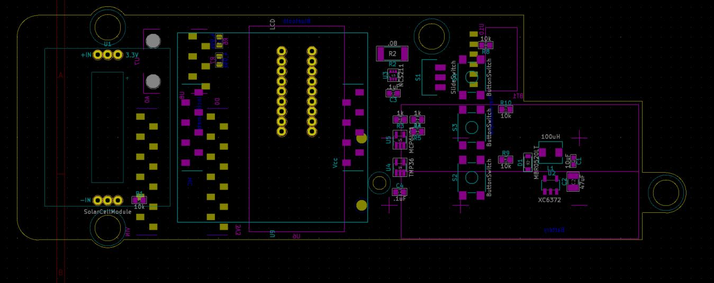

PCB Layout with traces

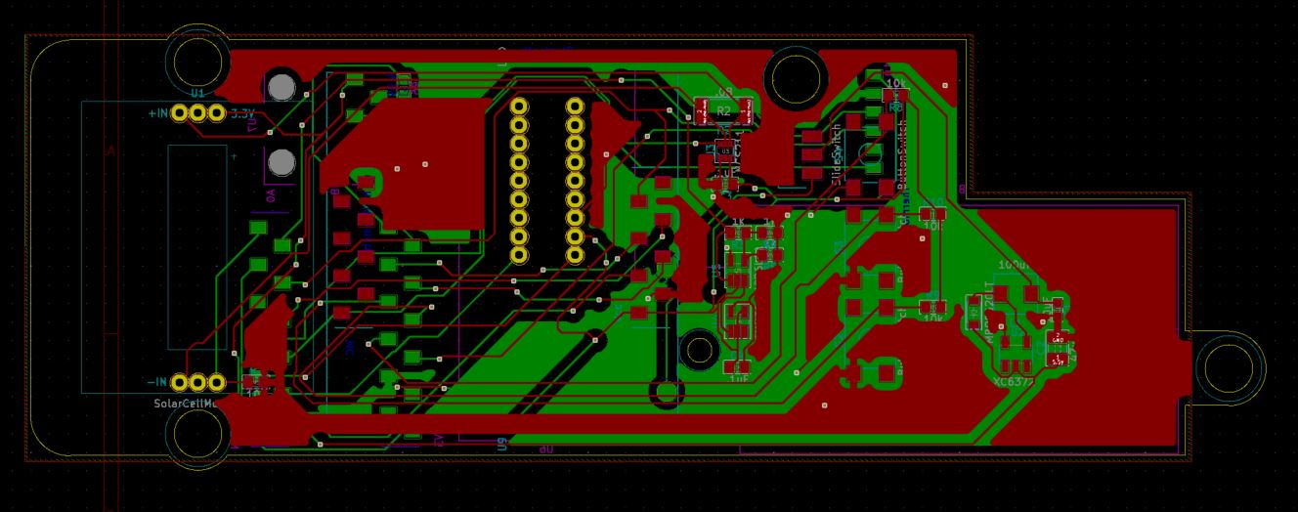

3D Top View

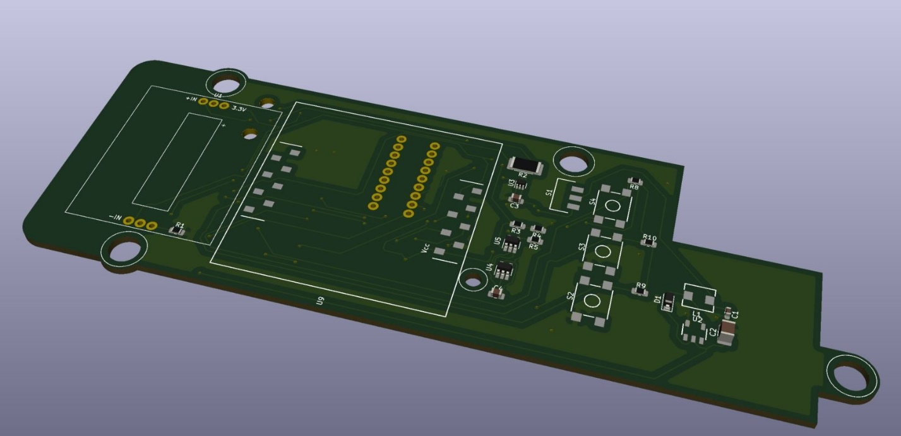

3D Bottom View

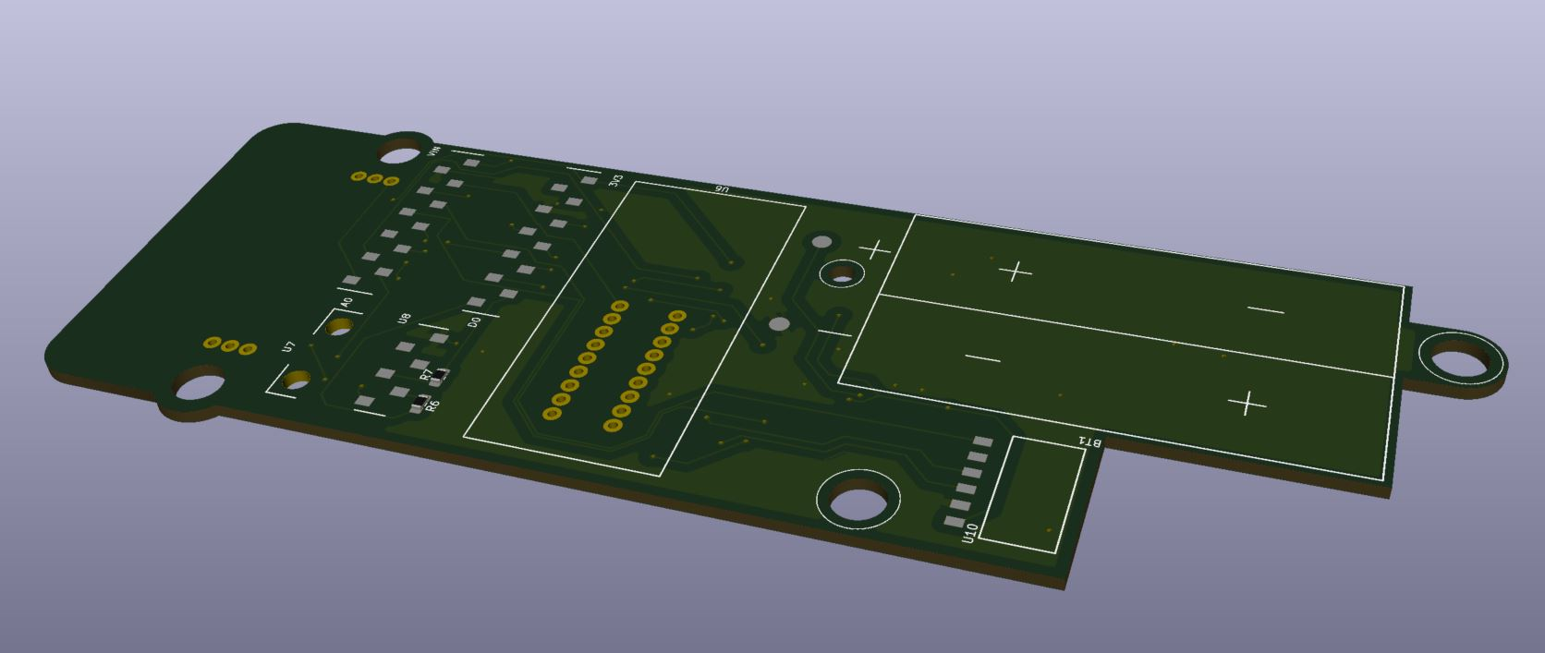

Solar Cell Module PCB layout

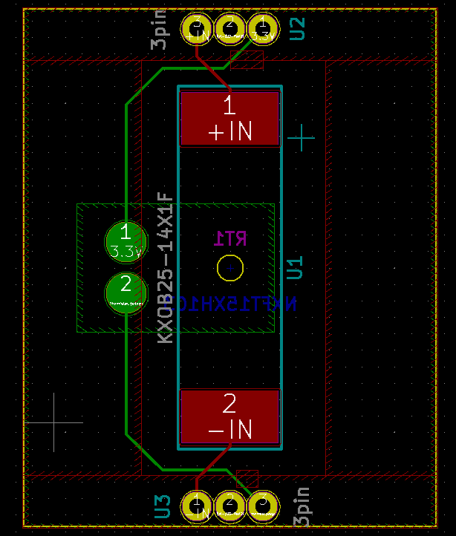

Solar Cell Module 3D (Top)

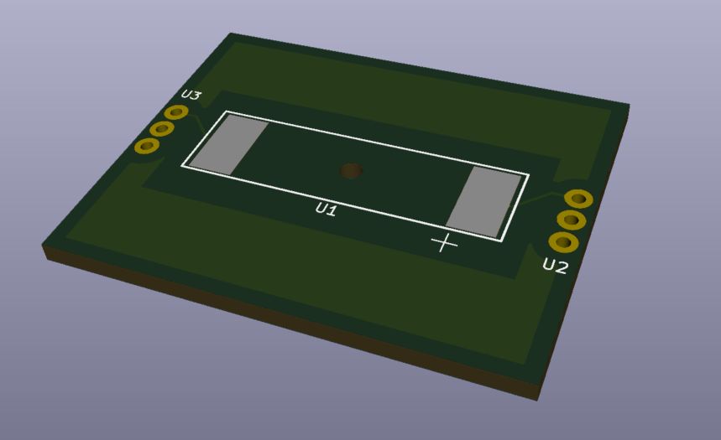

Solar Cell Module 3D (Bottom)

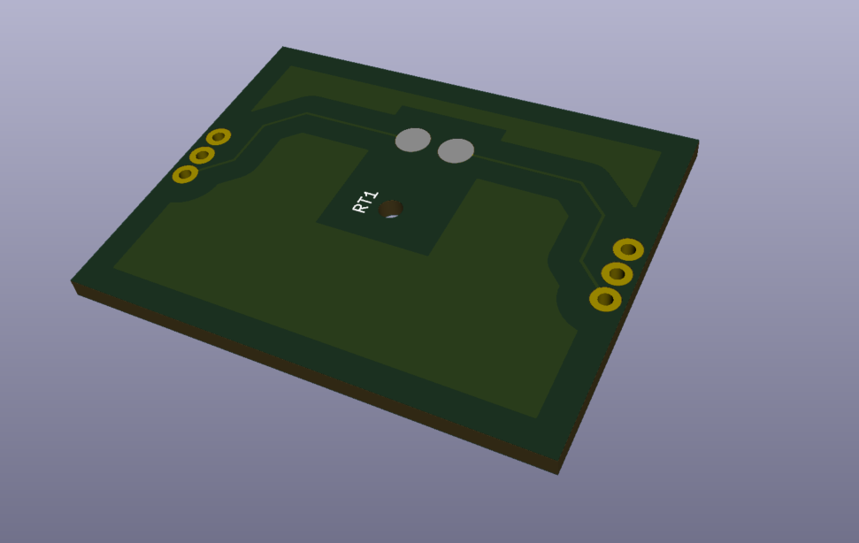

Case design 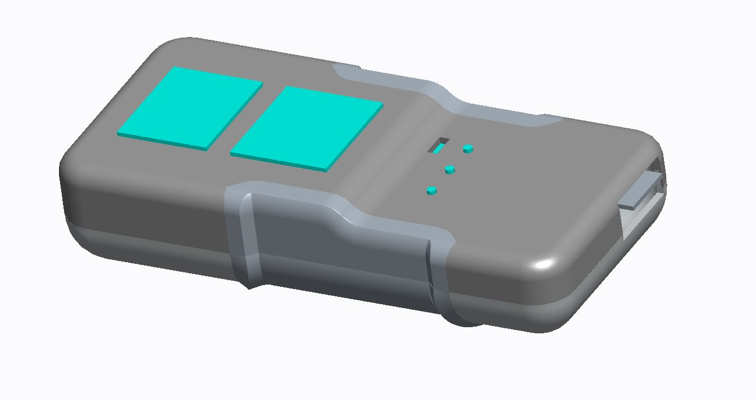

After the PCB was manufactured, all the components were soldered to the board. The final design is displayed below. The only module that was not soldered was the Bluetooth module.

Front View Back View

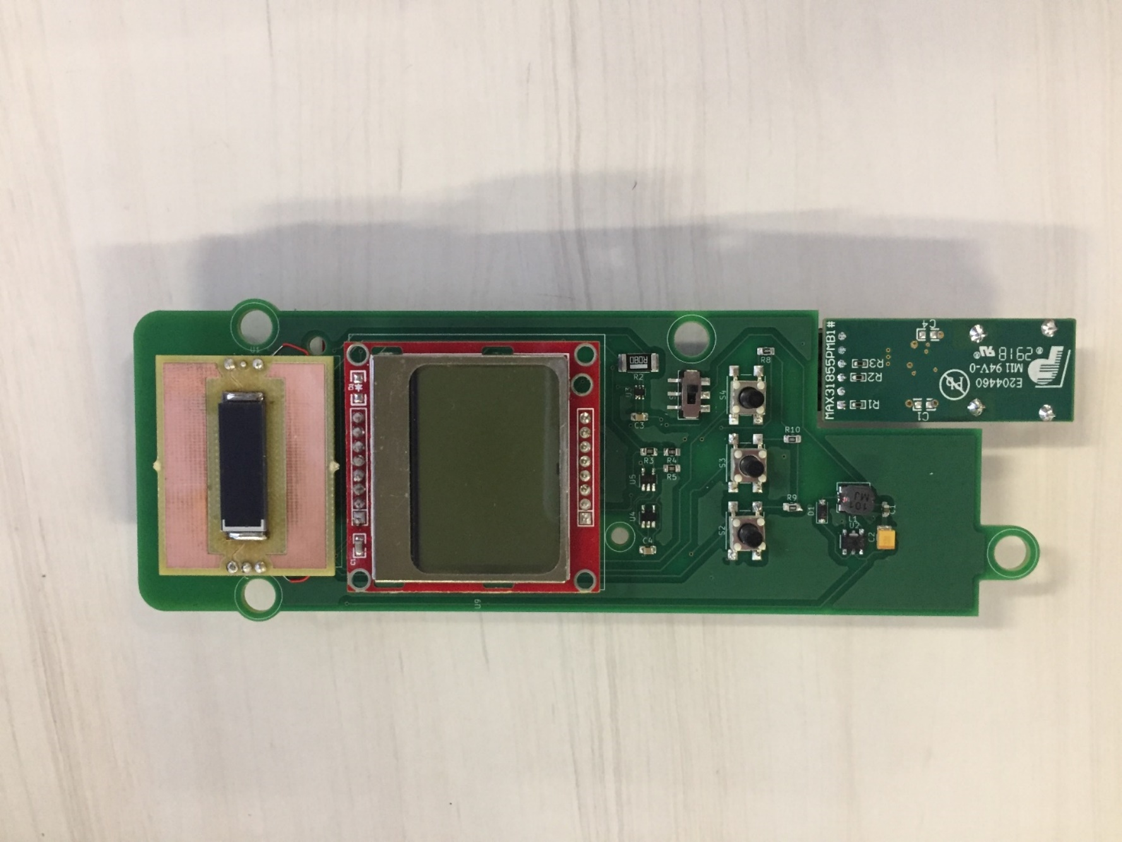 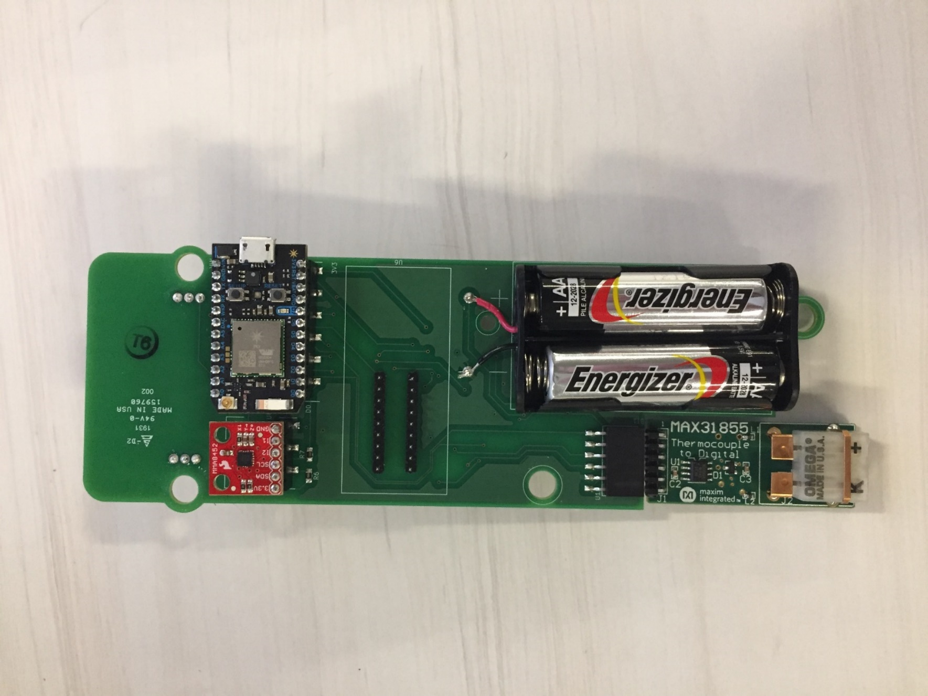

With Case

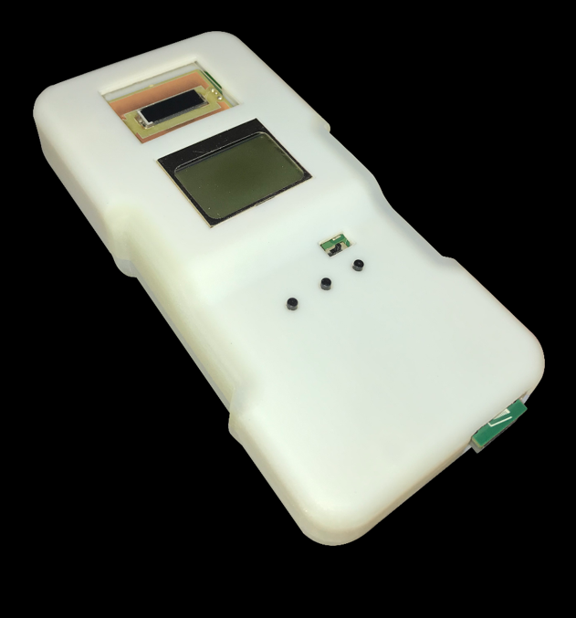

**Error Analysis**

See attachments page toward the end of the report for the error analysis of the design.

**Testing**

The final design was tested using the same procedure as the first design. The only difference is that the design was first tested without a case and then with a case. The standards require the cell to have a 160o viewing angle. Due to some calculation errors in the design process of the case, the cell did not have the full view that the standards require. So naturally, the measurement with the case produced lower irradiance values than measurements without the case attached. The graphs below represent how the second design measurements compare to the other meters.

Table 2

|  |  |  |  |
| --- | --- | --- | --- |
| Date & Time | SolSensor Irradiance (W/m2) | Seaward irradiance (W/m2) | Design (without case) Irradiance (W/m2) |
| Aug. 14th, 4:50 pm | 350-360 | 378-395 | 328-332 |
| Aug. 14th, 4:55 pm | 130 | 149-151 | 129-130 |
| Aug. 15th, 10:50 am | 600 | 619 | 567-568 |
| Aug. 15th, 12:45 am | 760 | 773-775 | 707-708 |
| Aug. 15th, 1:10 pm | 810 | 824-826 | 732-733 |

Table 3

|  |  |  |  |
| --- | --- | --- | --- |
| Day & Time | SolSensor Irradiance (W/m2) | Seaward Irradiance (W/m2) | Design (with case) Irradiance (W/m2) |
| Aug. 14th, 5:15 pm | 180 | 193-195 | 169-174 |
| Aug. 14th, 5:20 pm | 130 | 149-150 | 121-123 |
| Aug. 15th, 10:45 am | 590 | 613-616 | 539-540 |
| Aug. 15th, 12:45 pm | 760 | 769-772 | 682-683 |
| Aug. 15th, 1:10 pm | 810-820 | 824-826 | 719 |

**Data Analysis**

Looking at the graphs above, there is a clear pattern that formed that was not on data from the first design. The Seaward is always reading high of the Solmetric and the final design is always reading low. The graphs below represent the amount the final design differs at different irradiance values. This was found by averaging the range of irradiance at each interval and finding the difference between the Solmetric and the final design. The largest measurement range was 4 W/m2 for the design without the case and 5 W/m2 for the design with case. Error bars were added to represent the range.

There are several reasons for possible error. When the design was soldered, there was a few loose solder points and floating pads. In particular, the cell itself was a challenge to solder to the board. The cell could have gotten damaged in the soldering process because it becomes more fragile and loses its solid shape when heat is applied. This could have contributed to the overall error. When troubleshooting, the voltage across the shunt resistor was measured and the irradiance was found using hand calculations. The value found through the hand calculations matched the value displayed on the LCD. This concluded that the amplification after the shunt resistor and the software were correct. The error must have come from loose connections, error in solar cell specification (in particular it’s short circuit current), or damages to the cell.

**Conclusion**

The purpose of this project was to design portable handheld meter that would measure solar irradiance for solar panel installation and maintenance. Using a solar reference cell or a photodiode would be the most reasonable for a handheld meter due to size and cost. A photodiode sensor is cheap and can be cosine corrected, but does not match the solar spectrum of a solar panel and needs temperature correction (which is challenging). A solar reference cell can closely match solar panel spectral response and can be corrected for temperature, but are slightly more expensive than photodiodes and the packaging will most likely restrict the viewing angle to 160o. The reference cell was chosen for this design because it would match the solar spectrum that a panel would see better than a photodiode.

The first design was compared to the Solmetric SolSensor and the Seaward Solar Survey 200R. The design varied for the Solmetric SolSensor by an average of 6.8 W/m2. The Solmetric was used as a primary reference because it was designed to have a 2% error when measuring irradiance seen by solar panels. It is important to note that the Solmetric gave values in interval of 10. So, it was not the best reference to use, but was better than the Seaward. For future measurement and comparisons, it would be best to use a secondary standard pyranometer as a primary reference device.

A second design was built with all of the components inside a case to create an enclosed environment to decrease the affects of wind and dust. Larger error was found from comparing measurements. Most likely this error was coming from the solar cell itself. In addition, there is a possibility the first design had errors in the measurements, but the errors cause the readings to be closer to the value obtained from the reference devices.

Moving forward, more data should be gathered at different irradiance values for the second design to conclude if the trend on the “Irradiance Difference of Design compared to Solmetric” graph is correct. It would be interesting to see if the cell or the cell module are the reason for the error, so switching cells or reprinting the cell module would be a good idea. The specifications for the solar cells could vary from what is given and additional calibration may be needed. The standards also recommend that a 4-wire contact shunt resistor be used, but both designs have simple 2-contact resistors. Changing the resistor to see the affect on the overall irradiance value would also be a reasonable consideration. Most importantly, a more accurate primary reference device should be used when comparing the measurements.

**References**

1. <https://en.wikipedia.org/wiki/Pyranometer>
2. <http://www.seaward-groupusa.com/userfiles/curve-tracing.php>, “How Irradiance is Measurered”
3. "Photovoltaic Array Performance Model" - Sandia National Labs, D.L. King, W.E. Boyson, J.A. Kratochvill, Page 31
4. “Design of a Low Cost Irradiance Meter using a Photovoltaic Panel” – Joel Cruz-Colon, Luis Martinez-Mitjans, and Eduardo I. Ortiz-Rivera

**Attachments**

